The below attached are the Optimized Data with the following specs of the system:

1. Processor 13th Gen Intel(R) Core (TM) i7-13700K 3.40 GHz
2. Installed RAM 16.0 GB (15.8 GB usable)

Overview:

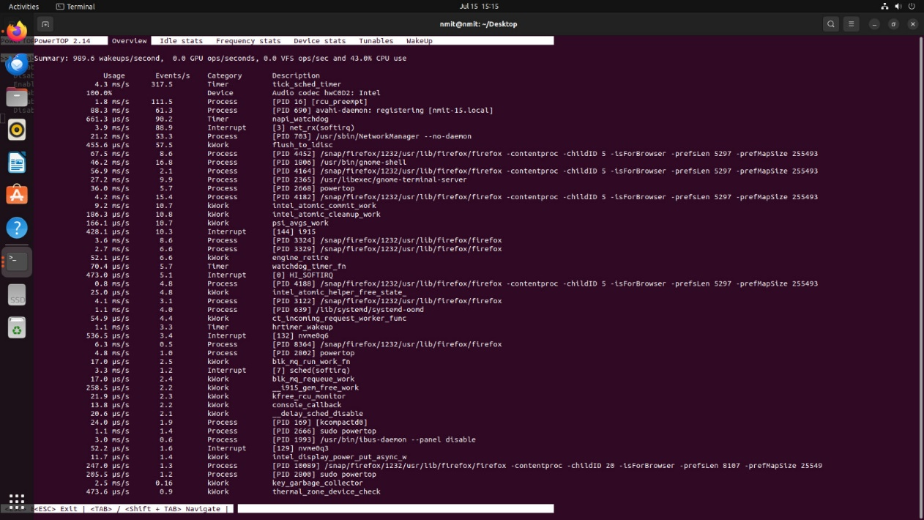

Idle Stats:

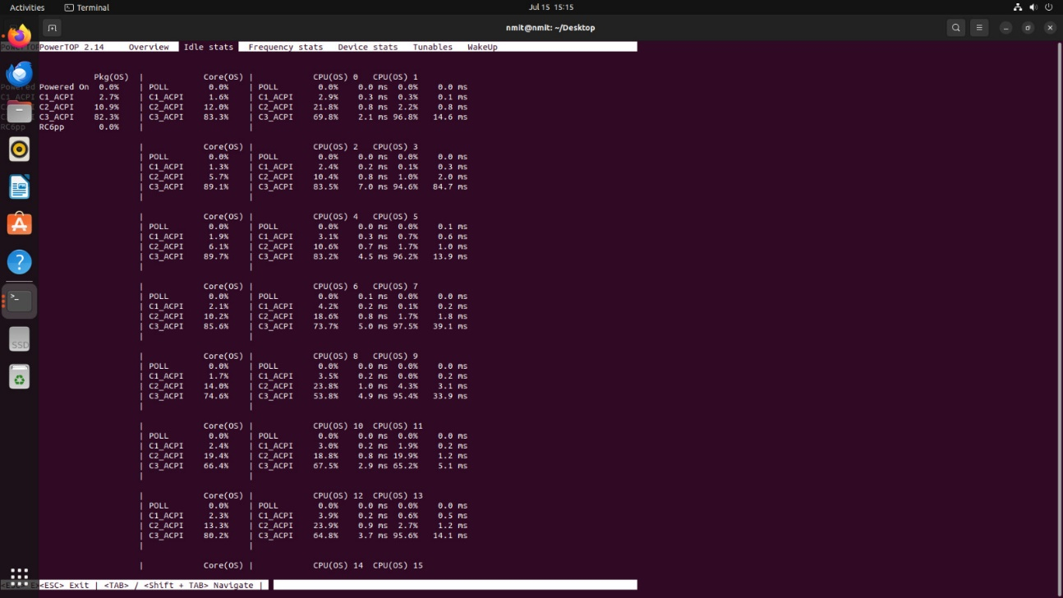

Frequency Stats:

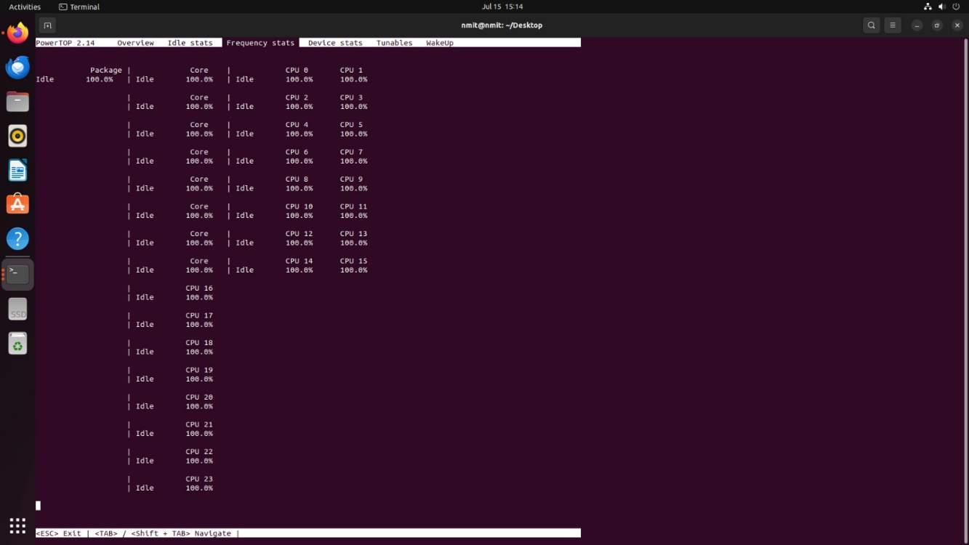

Device Stats:

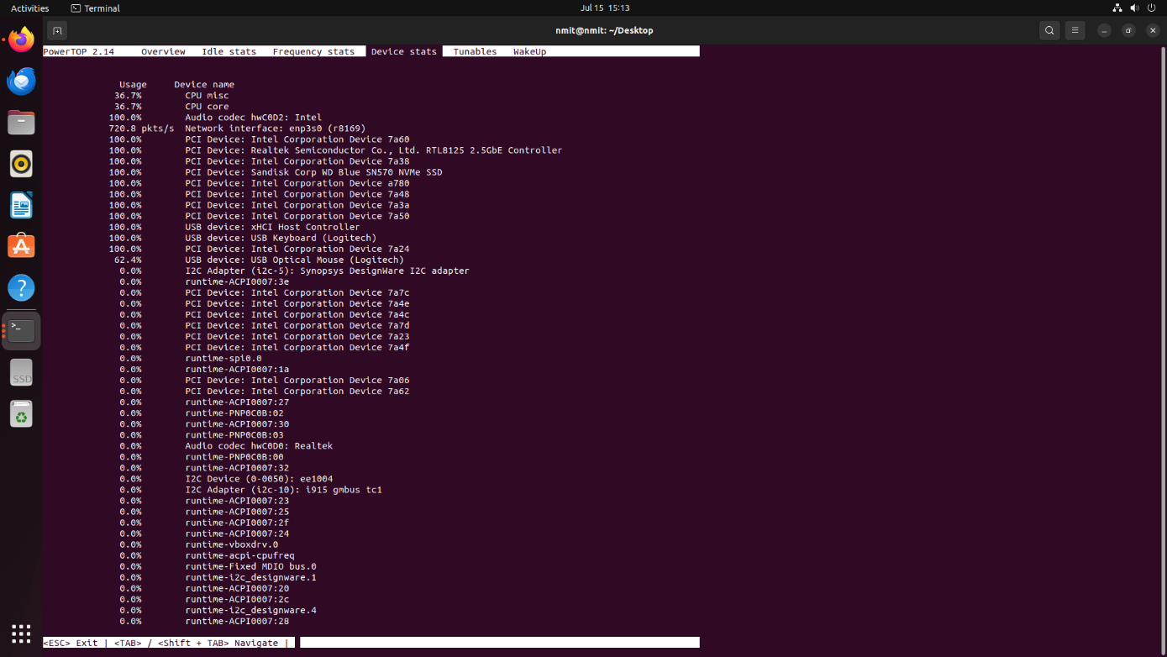

* Hence the system was tunned with the Tunable apt in powerTOP.